Selected stock: MercadoLibre (MELI)
Time frame analysed: 2022-1-3 to 2026-1-15
Exercise 1
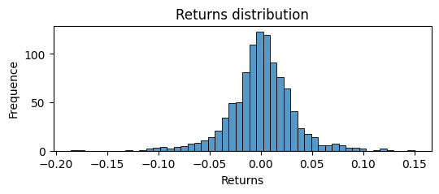
This distribution is not normal. Due to being mildly skewed to the left and heavy tails with a calculated excess Kurtosis of 3.9. Additionally, following graphs denote the significant outliers. Lastly, has a considerable Coefficient of Variation of 75%.
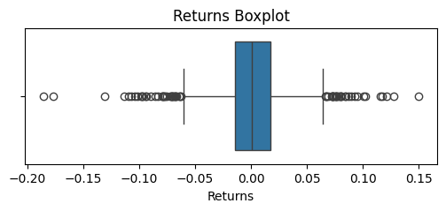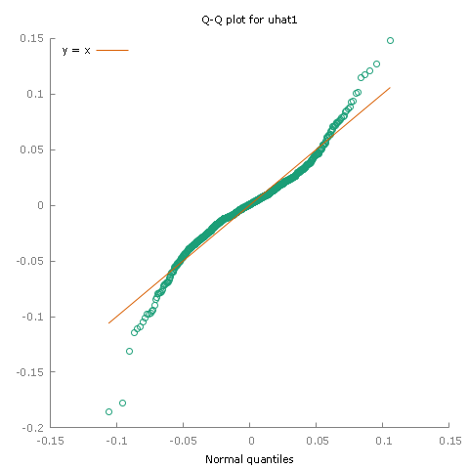
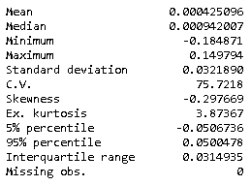
Considering this, in the parametric side we decided to test how a t-distribution fits.
But after reviewing results there is a big breach between the Value and Risk and Expected Shortfall of this t-distribution (-5,99% and -8,90%), and the ones evidenced by the non-parametric approaches (-17,60% and -18,11%). Consequently, it is needed to be modelled with non-parametric approaches.

Exercise 2
Reviewing autocorrelation of returns and an ARMA model capability to predict. By observing the scatterplot, we cannot denote any trend, it constitutes a cloud form that denies any autocorrelation between a return and its day before value.
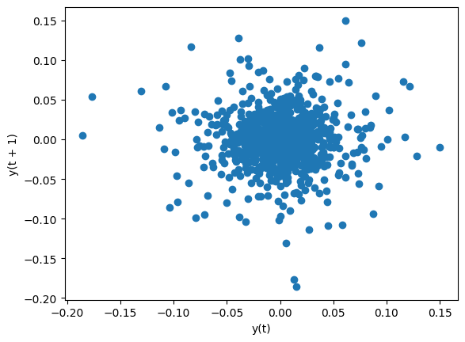
For one step ahead prediction, the model calculates a value of 0,0010 but with a truly high standard error of 0,03216.
The high standard deviation indicates substantial variability, making the model’s predictions unprecise. Furthermore, R squared and coefficients of the variables in the ARMA are very low. Even if the BIC value is fine, seems advisable just to use the mean in this case.
 | coefficient | std. error |  | z |  | p-value
const | -0,00347318 | 0,0020332 |  | -0,1708 |  | 0,8644
phi_1 | 0,0126276 | 0,744264 |  | 0,01697 |  | 0,9865
theta_1 | 0,00009999e-05 | 0,745982 |  | 0,000134 |  | 0,999
time | 1,54365e-06 | 3,47167e-06 |  | 0,4446 |  | 0,6566
Mean dependent var |  |  | 0,000425 |  | S.D. dependent var |  |  | 0,003219
mean of innovations |  |  | 0,000011 |  | S.D. of innovations |  |  | 0,032167
R-squared |  |  | 0,000374 |  | Adjusted R-squared |  |  | -0,0016
Log-likelihood |  |  | 2046,121 |  | Akaike criterion |  |  | -4082,24
Schawrz criterion |  |  | -4057,634 |  | Hannan-Quinn |  |  | -4072,89
Exercise 3
MACD-based trading strategy and its performance in MELI’s case.
 | BUY AND HOLD | MACD
MEAN | 0,08% | 0,24%
ST.DEV | 50,28% | 34,14%
SHARPE | 0,001505 | 0,007043

MACD-based trading strategy outperforms in every analysed aspect the simpler buy and hold strategy.

In this particular case, following MACD strategy is the best choice. As the movements on stock price allows such path.
Exercise 4
Squared excess returns seem autocorrelated with their past.
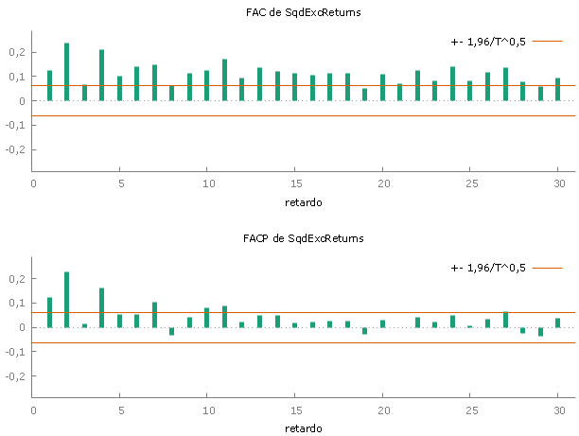
While analysing its dynamics, we first chose a GARCH with normal distribution. Our model gave both low p-values (<0,01) and Schwarz criterion (-9537,653), and a high chi-squared (306) which indicate that this model was appropriated at first instances. Conversely, when we compared the Unconditional Standard Error of 0,01532 and Standard deviation of the GARCH model of 0,00179772 we concluded that the model could not predict properly.
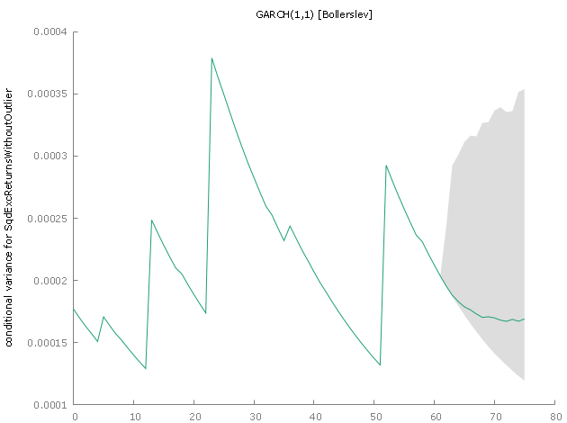
In this sense, we finally used GARCH t-variant and excluded outliers, which ended up giving us these results about the volatility which is reliable. In this stock and based in our analysis GARCH does seem to work properly.
 | coefficient | std. error |  | z |  | p-value
const | 0,0001827 | 1,87E-05 |  | 9,789 |  | 1,26e-022
omega | 4,6584E-07 | 5,4801e-06 |  | 0,08499 |  | 0,9323
alpha | 3,4336 | 36,74 |  | 0,09347 |  | 0,9255
beta | 0,9563 | 0,0464 |  | 20,59 |  | 3,25e-094
LLIK | 5806,279 | AIC | -11602,6
BIC | -11578,051 | HQC | -11593,2

Beta, the coefficient of past variance, is crucial to the prediction, with a low p-value and a convincing Z-score.

